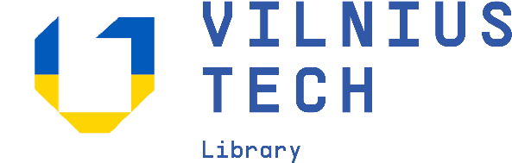

**Support Ukraine: Free VILNIUS TECH Electronic Books for Learning Lithuanian Language**

Vilnius Gediminas Technical (VILNIUS TECH) Library supports Ukraine integration in Lithuania and invites to use university author Regina Žukienė electronic books for learning Lithuanian language. The books are free accessible from VILNIUS TECH electronic books platform <https://ebooks.vilniustech.lt>:

[**„Basics of the Lithuanian Language for Russian Speakers“**](https://ebooks.vilniustech.lt/pdfreader/lietuvi-kalbos-pagrindai-rusakalbiams198244) **(2022)**

[**„Lithuanian Course for Foreigners: Theory and Practice“**](https://ebooks.vilniustech.lt/pdfreader/lietuvi-kalba-studentams-ir-u)

These books focuse on six topics necessary for successful communication in the Lithuanian language. Every topic contains speaking tasks, lexis and grammar material, and other practical as well as creative tasks. The books also provides the reader with simple reading that enhance the theoretical knowledge. The books presents a brief educational and practical course of the Lithuanian language. The learning material is designed aiming at the attainment of the basic user level (A1 Breakthrough according to the Common European Framework of Reference developed by the Council of Europe).

If you have any questions please contact Rūta +370 5 237 0686, [ebooks@vilniustech.lt](mailto:ebooks@vilniustech.lt)

For more information please visit website <https://vilniustech.lt/library>